SR Hospitals website Documentation
- I n t r o d u c t i o n
- INTRODUCTION
The project entitled as “SR Hospitals” for Treat the patient and make them healthy. The maintenance of each and every detail manually is a tough and tedious process. The main objective of this project is to computerize the activities performed in the concern. In this system viewing and updating of regular patient details, medical treatments details, doctors details, job details and employee details is easy because it reduces manual work.
This system is helpful in maintaining the record of patients. This project is developed in order to help the management to keep their overall records such as staff details and checkup details etc., the details are maintained by the secured login.

The administrator can view all the details and the details can also be updated. Thus the project helps the Hospital management to maintain their records. It is developed using Boostrap, java script and Xampp 8.2.12-0 .

- ABSTRACTION

The hospital is a place where all people comes sad but after they go happily. The health problem is main Concern across the country. Main reason behind the health disease is eating of unhealthy foods and chemical used items. The paper is innovative step to digitalize the hospital system throughout the city as well as villages. A step to improve the hospital system, which sets a platform to make everyone healthy. The real time hospital system will control the health disorders at each area.

- PROBLEM DEFINATION
The problem addressed by the by the hospital management system project is the inefficiency and complexity of managing hospital operation using traditional, manual, or outdated methods.
these challenges often lead to issue such as misplaces patient records, delays in appointment, billing errors, and difficulty in resource allocation. Additional, the lack of an integrated system hampers communication between departments, making it harder to provide seamless patient care. With the increasing volume of patients and data, manual processes become prone to errors and time -consuming. The hospital management system projects aims to resolve these issues by implementing a digital platform that streamlines patient registration, appointment scheduling, billing, inventory management , and staff coordination. This system will enhance operational efficiency, reduce errors, and improve the overall patient experience,

- OBJECTIVE OF THE STUDY
To understand the behavior of the Patients About “SR Hospital” & The Public Demand About the healthcare departments. Consumer prefers good hospital system for hygiene treatment aspect. The aim of the study is to find the patients satisfaction level towards hospital system. The study used both the primary data and secondary data for analysis.

- SCOPE OF THE STUDY
This Report will help to understand the Patients behavior taking a new Medical treatment, it also open the various factors which can affect the Decision. This Report Provides a frame of mind of patient, what are the expectations of consumer and up to how much level those expectation can meet. It Help the hospital to know the satisfaction level of existing patient based on service etc.
Hence a study was conducted to analysis the SR Hospitals with a relevant question

- E X I S T I N G A N D P R O P O S E D
S Y S T E M

- DESCRIPTION OF PROJECT
The hospital center project aims to create a modern healthcare facility dedicated to providing high-quality medical services to the community. the center will be equipped with advanced medical technology, states-of-the-art diagnostics and treatment equipment, and specialized departments to cater to a wide range of health needs. It will feature inpatient and outpatient services, emergency care, surgical suites, and dedicated spaces for rehabilitation and preventive care programs. Designed with patient comfort and efficiency in mind, the hospital will also include modern infrastructure , eco-friendly features, and a compassionate team of healthcare professionals committed to delivering exceptional care. This project seeks to improve health care accessibility and outcomes while fostering healthier community.

- EXISTING SYSTEM
In the existing system, all the operations are done only manually and hence take many efforts in the process of information passing. Since all the details have to be maintain to manage the system each and every records like patient details, medical treatments details, doctors details, job details and employee details have to be maintained. In the existing system though making entries is easy but recollecting information about courier or patient details is a tough task. Hence a new system has to be developed to maintain all the data.
- PROPOSED SYSTEM
The aim of proposed system is to develop a system of improved facilities. The proposed system can overcome all the limitations of the existing system. The system provides proper security and reduces the manual work. The new system can maintain all the data easily like patient details, medical treatments details, doctors details, job details ,employee details etc,. Retrieval of any information from the system is very quick and easy process.

- ADVANTAGES
The system is very simple in design and to implement. The system requires very low system resources and the system will work in almost all configurations. It has got following features. All the details are stored according to their id in every module for easy retrieval.
1. Computerized maintenance of records.
2. Daily transactions and payment details are updated daily.
3. Records are safe and secure.
4. Consumes very small amount of time.
5. Requires low man power.
6. Any information can be fetched easily.
7. Enhance Patient Experience .

- DISADVANTAGES
1. High implementation costs .
2. Technical Issues.
3. Data security concerns.
4. Internet Dependence.
5. Integration challenges.
6. Training Needs.

- SYSTEM ANALYSIS
- SYSTEM ANALYSIS
System analysis is a process of gathering and interpreting facts, diagnosing problems and the information to recommend improvements on the system. It is a problem solving activity that requires intensive communication between the system users and system developers. System analysis or study is an important phase of any system development process. The system is studied to the minutes detail and analyzed. The system analyst plays the role of the interrogator and dwells deep into the working of the present system. The system is viewed as a whole and the input to the system are identified. The outputs from the organizations are traced to the various processes. System analysis is concerned with becoming aware of the problem, identifying the relevant and decisional variables, analyzing and synthesizing the various factors and determining an optimal or at least a satisfactory solution or program of action.

- FEASIBILITY STUDY
The demand for healthcare services is constantly rising and there are a number of local doctor providing good quality of health service. The services are becoming of good. This trend has led to strong growth on health condition on Bharat. The focus of the service would be to provide clean and hygienic health care service.

- TECHNICAL FEASIBILITY
This assessment focuses on the technical resources available to the organization. It helps organizations determine whether the technical resources meet capacity and whether the technical team is capable of converting the ideas into working systems. Technical feasibility also involves the evaluation of the hardware, software, and other technical requirements of the proposed system.

- OPERATIONAL FEASIBILITY
This assessment involves undertaking a study to analyze and determine whether and how well the organization's needs can be met by completing the project. Operational feasibility studies also examine how a project plan satisfies the requirements identified in the requirements analysis phase of system development.
- SYSTEM REQUIREMENT SPECIFICATION
- REQUIREMENT SPECIFICATION
Requirements specification is a critical part of the Requirements Engineering process. It is the third phase, after Requirements Capture and Analysis. The goal is to create a document, or Requirements Specification, with the corresponding level of detail. This document will contain all requirements that are to be imposed on the design and verification of the product. It will also contain other related information necessary for the design, verification, and maintenance of the product.

- INFRASTRUCTURE REQUIREMENTS
A software development infrastructure typically consists of tools, processes, and services used to develop, test, deploy, and manage software applications. The most common components of a software development infrastructure include source control management systems, build servers, testing frameworks, and deployment pipelines, When all these components are built out, they work together to provide a streamlined way to develop software applications.

- TOOLS & PLATFORM USED
With its language enhancements and its tight integration into the .NET Framework, Visual Basic is a thoroughly modernized language that will likely become the premier development tool for creating a wide range of .NET applications. In the past, Visual Basic was often seen as a “lightweight” language that could be used for particular kinds of tasks, but was wholly unsuitable for others.

- FRONT END
Front End – Boostrap.min.css
- BACK END
Back End - XAMPP 8.2.1 (MYSQL 5.0)
- HARDWARE REQUIREMENTS
Hardware Requirements
- Processor: Intel core i3 6100t or Above Version.
- RAM : 4GB Or 8GB
- Monitor
- Mouse
- Operating System: Windows 7, Windows 8, Windows 10 or above version.

4.4. SOFTWARE REQUIREMENTS
Software Requirements
• Operating system : Windows 7, Windows 8, Windows 10 or above version.
• Coding Language : HTML,CSS
• Database : XAMPP – 8.2.12, MySQL – 5.0

- SYSTEM DESIGN
- System Design
System design is the process of designing the elements of a system such as the architecture, modules and components, the different interfaces of those components and the data that goes through that system.
- Elements of a System
• Architecture – This is the conceptual model that defines the structure, behavior, and more views of a system. We can use flowcharts to represent and illustrate the architecture.
• Modules – These are components that handle one specific task in a system. A combination of the modules makes up the system.
• Components – This provides a particular function or group of related functions. They are made up of modules.
• Interfaces – This is the shared boundary across which the components of the system exchange information and relate.
• Data – This is the management of the information and data flow.

- ARCHITECTURE
The architecture of a system reflects how the system is used and how it interacts with other systems and the outside world. It describes the interconnection of all the systems components and the data link between them. The architecture of a system reflects the way it is thought about in terms of its structure, functions, and relationships.
- Model
The modules of this project are
  - Patient Details
  - Doctor Details
  - Appointment Details
  - Contacts Details
  - Users Details
  - Job Details
  - Service Details
  - Electronic medical records (EMR)
  - Bed and Emergency management
- MODEL USED IN PROJECT
Waterfall model
The waterfall Model outlines the product advancement prepares in a straight consecutive stream; subsequently it is likewise alluded to as a direct successive life cycle model. This implies that any stage in the advancement procedure starts just if the past stage is finished.
Taking after is a diagrammatic representation of diverse periods of waterfall model.
The successive stages in Waterfall model are:
- Requirement Gathering and analysis: Every conceivable prerequisite of the framework to be produced are caught in this stage and reported in a necessity particular doc.
- System Design: The prerequisite details from first stage are contemplated in this stage and framework configuration is arranged. Framework Outline helps in determining equipment and framework prerequisites furthermore helps in characterizing general framework structural engineering.
- Implementation: With inputs from framework plan, the framework is initially grown in little projects called units, which are coordinated in the following stage. Every unit is created and tried for its usefulness which is alluded to as Unit Testing.
- Integration and Testing: All the units grew in the execution stage are incorporated into a framework subsequent to testing of every unit. Post reconciliation the whole framework is tried for any issues and disappointments.

- Deployment of system: Once the practical and non-useful testing is done, the item is conveyed in the client environment or discharged into the business.
- Maintenance: There are a few issues which come up in the customer environment. To alter those issues patches are discharged. Likewise to upgrade the item some better forms are discharged. Upkeep is done to convey these adjustments in the client environment.

Every one of these stages are fell to one another in which advance is seen as streaming consistently downwards (like a waterfall) through the stages. The following stage is begun strictly when the characterized arrangement of objectives are accomplished for past stage and it is closed down, so the name "Waterfall Model".

- CONTEXT DIAGRAM
DATA FLOW DIAGRAM
The dataflow diagram (DFD) is one of the most important tools used by system analysts. Data Flow diagrams are made up of a number symbols, which represent system components. Most dataflow modeling methods use four kinds of symbols. These symbols are used to represent four kind of the system components processes, stores ,data flows and external entities Circles in DFD represent processes, data flow represented by a thin line in the DFD and each data store has a unique name and represented by open rectangles and square are rectangle represents external entities.

A Data Flow Diagram (DFD) is a traditional visual representation of the information flows within a system. A neat and clear DFD can depict the right amount of the system requirement graphically. It can be manual, automated, or a combination of both.
It shows how data enter and leaves the system, what changes the information, and where data is stored.

The objective of a DFD is to show the scope and boundaries of a system as a whole. It may be used as a communication tool between a system analyst and any person who plays a part in the order that acts as a starting point for redesigning a system. The DFD is also called as a data flow graph or bubble chart.

The following observations about DFDs are essential:
- All names should be unique. This makes it easier to refer to elements in the DFD.
- Remember that DFD is not a flow chart. Arrows is a flow chart that represents the order of events; arrows in DFD represents flowing data. A DFD does not involve any order of events.
- Suppress logical decisions. If we ever have the urge to draw a diamond-shaped box in a DFD, suppress that urge! A diamond-shaped box is used in flow charts to represents decision points with multiple exists paths of which the only one is taken. This implies an ordering of events, which makes no sense in a DFD.
- Do not become bogged down with details. Defer error conditions and error handling until the end of the analysis.
- Circle: A circle (bubble) shows a process that transforms data inputs into data outputs.
- Data Flow: A curved line shows the flow of data into or out of a process or data store.
- Data Store: A set of parallel lines shows a place for the collection of data items. A data store indicates that the data is stored which can be used at a later stage or by the other processes in a different order. The data store can have an element or group of elements.
- Source or Sink: Source or Sink is an external entity and acts as a source of system inputs or sink of system outputs.

DFD 0 Level

REPORT
MANAGE
na
ADMIN

DFD 1 Level
PROJECT REPORT
Profit & Loss
Take Order
Manage Expenses
Add Product
Cash Receipt
login
ADMIN

DFD 2 Level
ADMIN
login
Cash Receipt

Cash Receipt
Cash Receipt
Cash Receipt

Cash Receipt
Cash Receipt

PROJECT REPORT

- ER DIAGRAM
An Entity Relationship Diagram (ERD) is a visual representation of different entities within a system and how they relate to each other. It is a tool used to design and model relational databases, and shows the logical structure of the database. ER diagrams use symbols to represent entities, attributes, and relationships, which help to illustrate the relationships between the entities in the database. It consists of entities (which represent objects or concepts, like “Customer” or “Product”) and relationships (which represent how these entities are connected or interact with each other, like “owns” or “buys”).

- Symbols Used in ER Diagrams
- Rectangles: This Entity Relationship Diagram symbol represents entity types
- Ellipses: This symbol represents attributes
- Diamonds: This symbol represents relationship types
- Lines: It links attributes to entity types and entity types with other relationship types
- Primary key: Here, it underlines the attributes
- Double Ellipses: Represents multi-valued attributes

- Entity
An Entity may be an object with a physical existence a particular person, car, house, or employee or it may be an object with a conceptual existence a company, a job, or a university course.
- Weak Entity
- Strong Entity

- Attributes
Attributes are the properties that define the entity type. For example, Roll_No, Name, DOB, Age, Address, and Mobile_No are the attributes that define entity type Student. In ER diagram, the attribute is represented by an oval.

- Relationship
A Relationship Type represents the association between entity types. For example, „Enrolled in‟ is a relationship type that exists between entity type Student and Course. In ER diagram, the relationship type is represented by a diamond and connecting the entities with lines.
Types of relationship are as follows:
a. One-to-One Relationship
b. One-to-many relationship
c. Many-to-one relationship
d. Many-to-many relationship
---------------------------------------------------------------------------------------------------------------------
---------------------------------------------------------------------------------------------------------------------
---------------------------------------------------------------------------------------------------------------------
---------------------------------------------------------------------------------------------------------------------
---------------------------------------------ER DIAGRAM----------------------------------------------
---------------------------------------------------------------------------------------------------------------------
---------------------------------------------------------------------------------------------------------------------
---------------------------------------------------------------------------------------------------------------------
---------------------------------------------------------------------------------------------------------------------

- USER INTERFACE DESIGN

- SCREEN SHOTS
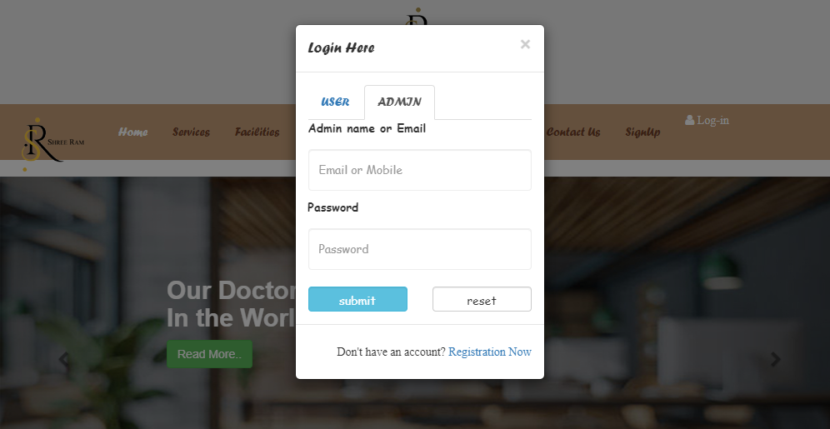
LOGIN Page

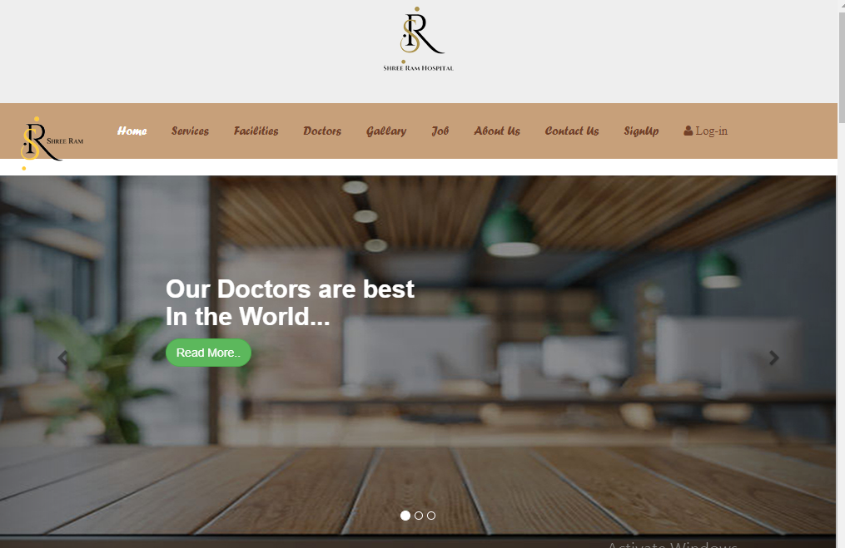
HOME_Page

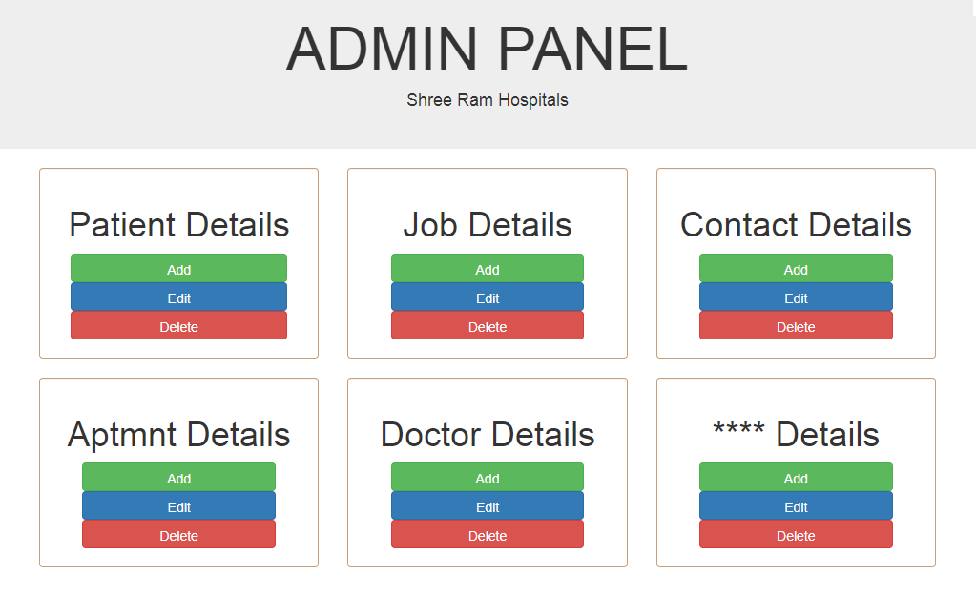
ADMIN Panel

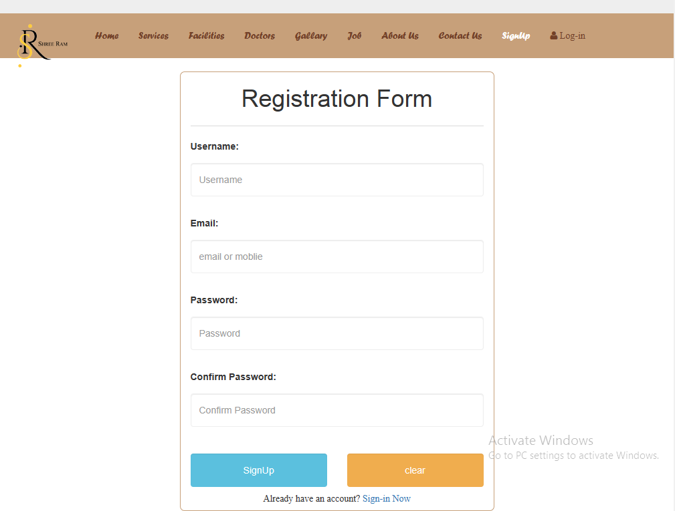
Sign Up Page

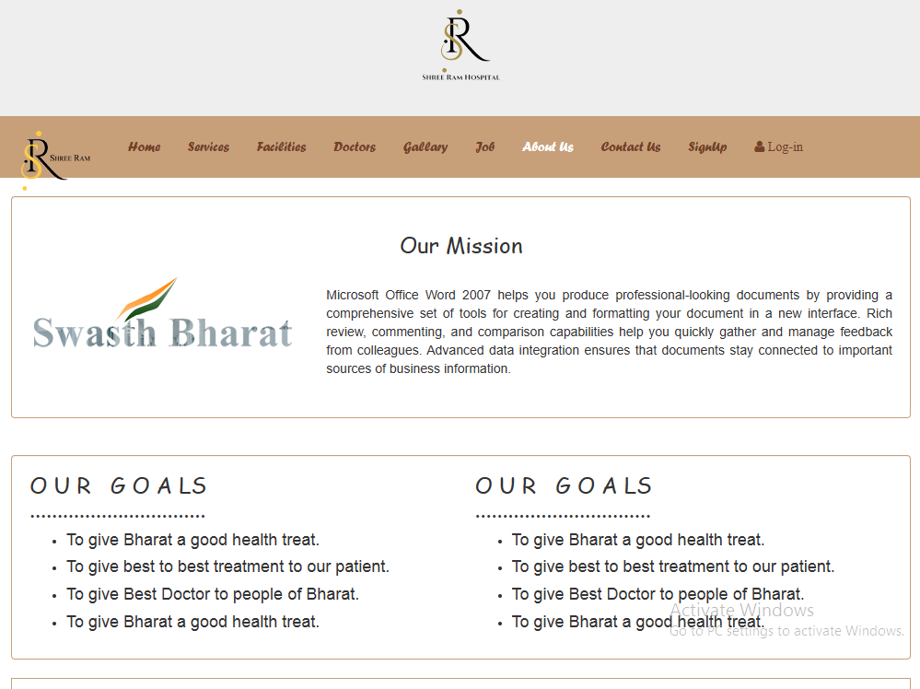
About Us Page

Inquiry Page
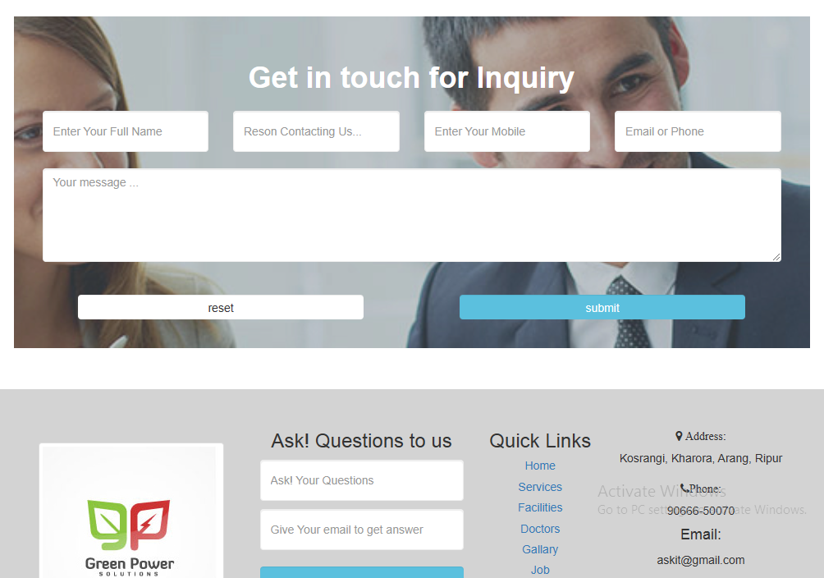

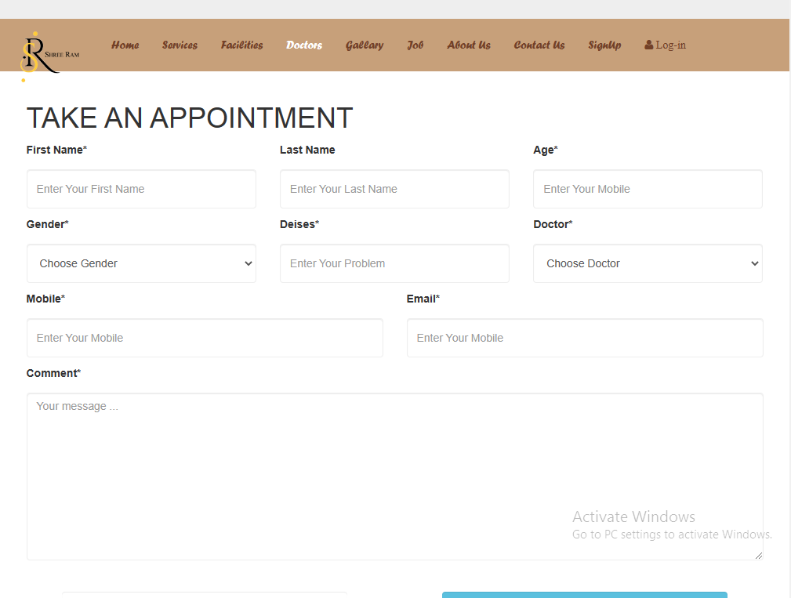
Appointment page

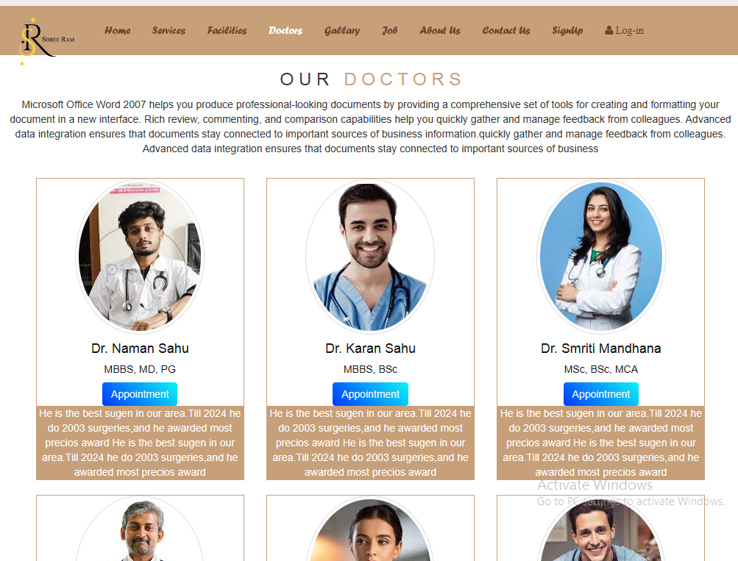
Doctors Page

- DATA BASE

Users
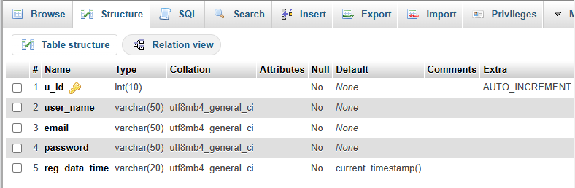

Patient_reg
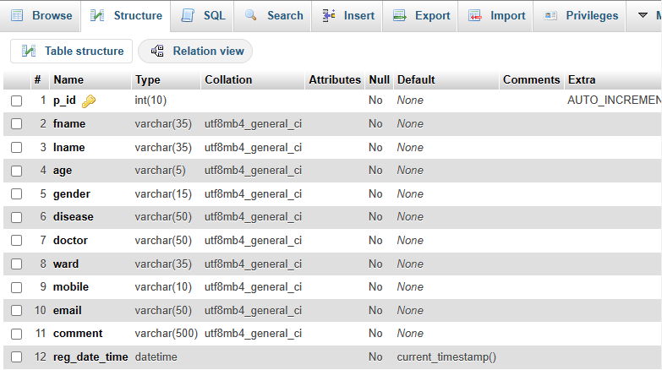

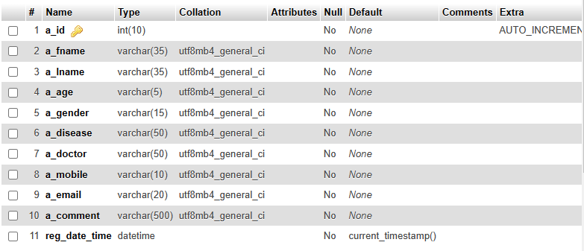
Appointment

Doctor
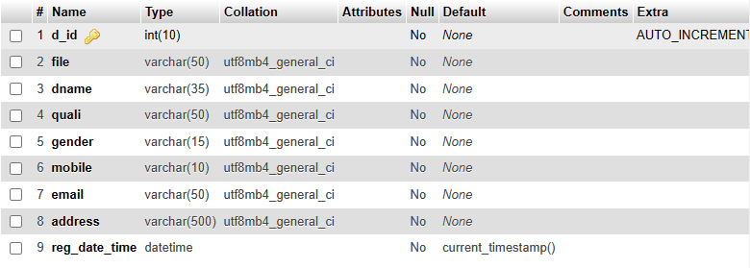
Contact_Us
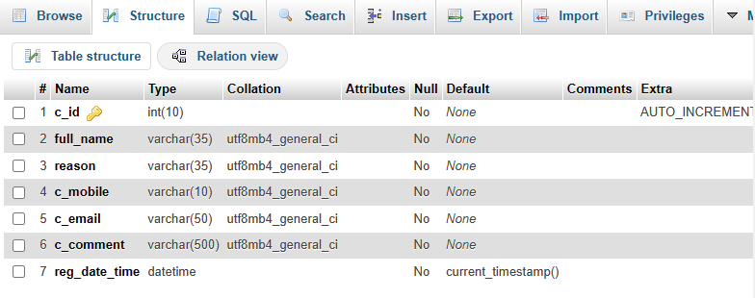
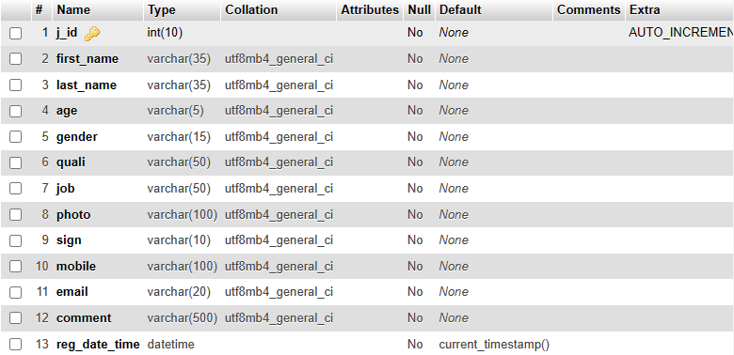
Job
- CODING
Login PHP
<?php
include "conn.php"
?>
<?php
session_start();

include "conn.php";

if(isset($_POST['contact']))
{
$full_name = $_POST['full_name'];
$reason = $_POST['reason'];
$c_mobile = $_POST['c_mobile'];
$c_email = $_POST['c_email'];
$c_comment = $_POST['c_comment'];

$query = "select * from contact_us where c_email='{$c_email}'";
$res = mysqli_query ($conn, $query);

if (mysqli_num_rows($res) > 0)
{
echo "<div class='alert alert-warning alert -dismisible fade in'>
<a href='#' class='close' data-dismiss='alert' aria-lable='close'>&times;</a>
<strong>warning!</strong>This email is used , Try another one please!</div>";
}
else
{
$sql = "Insert into contact_us(full_name, reason, c_mobile, c_email ,c_comment)Values ('$full_name','$reason','$c_mobile','$c_email','$c_comment')";

$result = mysqli_query($conn, $sql);

if ($result)
{
echo "<div class='alert alert-success alert-dismisible fade in'>
<a href='#' class='close' data-dismiss='alert' aria-label='close'>&times;</a>
<strong>success !<strong>You are register succesfully!!!</div>";
echo"<a href='registration.html'><button class='btn btn-info'>Go Registration Page</button></a>";
}
else
{
echo "<div class='message'><p>This email is used, Try another On please !</p></div><br>";
}
}

}
else
{
?>
Login HTML
<!--Modal-->
<div class="modal fade" id="myModal" role="dialog">
<div class="modal-dialog modal-sm ">
<div class="modal-dialog modal-sm ">
<div class="modal-content divbg9">
<div class="modal-header">
<button type="button" class="close" data-dismiss="modal">&times; </button>
<h4 class="modal-title Mycolor1">Login Here</h4>
</div>

<div class="modal-body">
<ul class="nav nav-tabs">
<li class="active"><a data-toggle="tab" href="#user">USER</a></li>
<li><a data-toggle="tab" href="#admin">ADMIN</a></li>
</ul>

<div class="tab-content">
<div id="user" class="tab-pane fade in active">
<form class="family5" action="http://localhost/naman/SR_Hospitals/login.php" method="post">
<label>Username,Email or Mobile</label>
<input class="form-control" type="email number" name="email2" placeholder="Email or Mobile" required>

<label>Password</label>
<input class="form-control" type="password" name="password" placeholder="Password" required>

<div class="row">
<div class="col-sm-6">
<input class="btn btn-info btn-sr-login" name="login" type="submit" value="submit" >
</div>
<div class="col-sm-6">
<input class="btn btn-default btn-sr-login" type="reset" value="reset">
</div>
</div>
</form>
</div>

<div id="admin" class="tab-pane fade">
<form class="family5" action="http://localhost/naman/SR_Hospitals/login.php" method="post">
<label>Admin name or Email</label>
<input class="form-control" type="email number" name="email2" placeholder="Email or Mobile" required>

<label>Password</label>
<input class="form-control" type="password" name="password" placeholder="Password" required>

<div class="row">
<div class="col-sm-6">
<input class="btn btn-info btn-sr-login" name="login" type="submit" value="submit" >
</div>
<div class="col-sm-6">
<input class="btn btn-default btn-sr-login" type="reset" value="reset">
</div>
</div>
</form>
</div>

</div>
</div>

<div class="modal-footer">
<h5 class="font1 Mycolor1">Don't have an account? <a href="Registration.html">Registration Now </a></h5>
</div>
</div>
</div>
</div>
</div>

